Contents

1. Conversational AI: 3

**Module 1 : Voice assistant** 3

**Module 2 : Duck Duck GoSearch engine** 4

**Module 3: Infosec agent:** 6

**1.** **Llama Index Chat engine:** 6

**2.** **Llama Index React agent using query engine tool** 6

**3.** **Llama Index Context retriever agent using query engine tool** 6

**4.** **Llama index OpenAIAgent with Duck Duck go tool** 7

**5.** **Llama index OpenAIAgent with Google tool** 7

**6.** **Lang chain – RetrievalQAWithSourcesChain - Agent stacking:** 7

**7.** **Langchain agent:** 7

**Module 4: Conversational agent – Lang chain – Context awareness** 8

**Module 5: Fine tuning:** 9

**Module 6: Choosing vector database** 10

**Module 7: Indexing, Retrieval, Hybrid search** 11

**Module 8: Presentation engine** 11

**Module 9: Fast API – PDF data source Discrepancy checker** 11

**Module 10: Unittest with python** 11

**Module 11: Azure function apps** 12

**Module 12: Snowflake Database** 12

**Module 13: Seq to Seq Chatbot implementation** 15

**Module 14: Chatbot architecture:** 17

**Module 15: Git hub:** 18

**Module 16: Tech Lead:** 18

7. Sales Agent: 20

Module 1: Conversation history: 20

Module 2: Document finder 20

Module 3: Presentation Engine 20

Module 4: Regulation controls mapping 20

Module 5: LinkedIn Leads identifier 20

8. Wells Fargo - Topic modelling in NLP: 20

9. Optum – Chatbot: 21

10. Optum – Agent call note summarization: 21

11. ITC – Sentiment analysis: 21

12. Cognizant Fraud analysis in NLP: 21

13. Key concepts to know in NLP: 21

1. Tokenizer: 21

2. Word-Piece ( BERT/DistilBERT) 22

3. Unigram (XLNet, ALBERT) 22

4. Sentence-piece(Albert, XlNet, T5) 22

5. Byte pair encoding (GPT2, RoBERTa) 22

6. 22

14. ML ops: 22

15. Finetuning LLMs: 23

1. When to use finetuning: 23

2. Model merging and Mixture of experts(MOE) 24

a. Model kit – SLERP, DARE TIES 24

b. MoE based on Router 24

3. Quantization – process of converting from high memory to low memory format 24

• Full precision/ Half precision 24

• Symmetric quantization: 24

• Asymmetric: 24

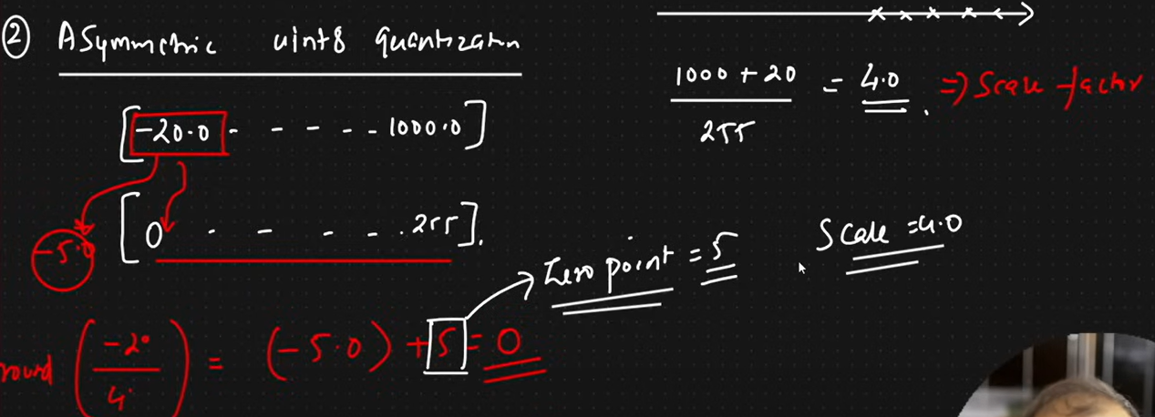 24

• Calibration – Model quantization problems 25

• Modes of Quantization 25

4. QLoRA/LoRA: 25

5. 25

16. Advanced Python: 25

1. Magin methods: 25

2. 25

# Conversational AI:

<https://medium.com/@onkarmishra/using-langchain-for-question-answering-on-own-data-3af0a82789ed>

<https://python.langchain.com/v0.2/docs/concepts/#retrievers>

## **Module 1 : Voice assistant**

import wave

import pyaudio

import numpy as np

from scipy.io import wavfile

from faster_whisper import WhisperModel

Step 1: Transcribe an audio:

Transcribes an audio file using the Whisper model. Uses beam search (beam_size=7) to enhance transcription accuracy. Joins the segments into a single transcription string.

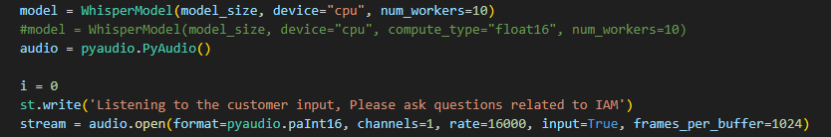

def transcribe_audio(model, file_path):

    segments, info = model.transcribe(file_path, beam_size=7)

    transcription = ' '.join(segment.text for segment in segments)

    return transcription

**Step 2: Convert the generated text by LLM to audio:**

**pygame**: A library used for writing video games, here used for playing audio. **gTTS**: A library for interfacing with the Google Text-to-Speech API. **pygame.mixer.init()**: Initializes the pygame mixer for audio playback. **pygame.mixer.music.load(temp_audio_file)**: Loads the audio file into the mixer.

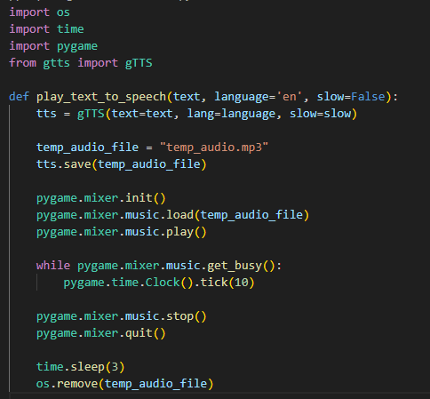

## **Module 2 : Duck Duck GoSearch engine**

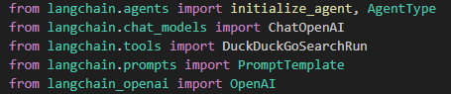

**ChatOpenAI: Initializes the ChatOpenAI model with gpt-3.5-turbo and the API key.**

**DuckDuckGoSearchRun: Initializes the DuckDuckGo search tool.**

**initialize_agent: Combines the LLM and the search tool into an agent with the ZERO_SHOT_REACT_DESCRIPTION type, which can perform actions based on descriptions without prior training.**

**return search_agent: Returns the initialized search agent.**

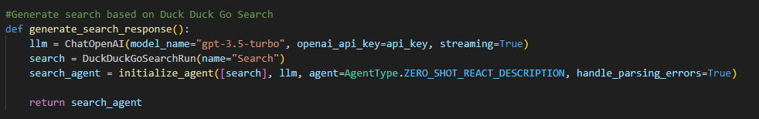

Summary Engine:

1. Install the dependency:

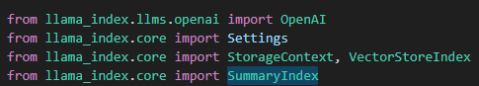

1. Load the documents:

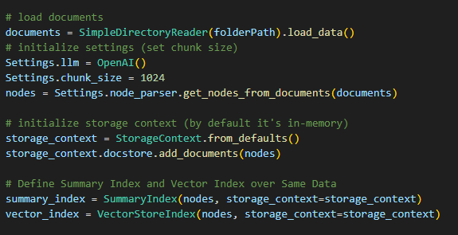

1. Create tools:

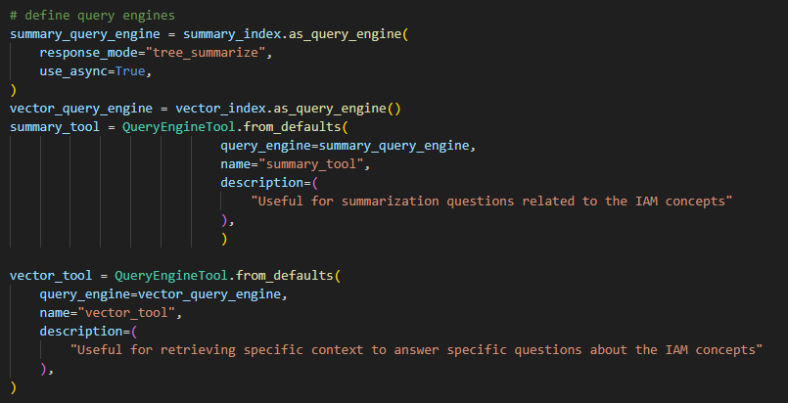

1. Summary based on the given contextual document 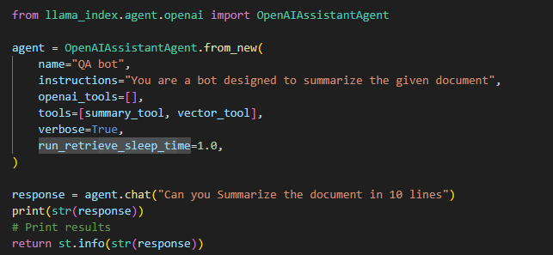

**Recommendation engine:**

* **llm = OpenAI()**: Instantiates the OpenAI LLM model.
* **template**: Defines a template for generating a recommendation prompt.
* **PromptTemplate**: Creates a prompt template with the input variable topic.
* **prompt_query = prompt.format(topic=topic)**: Formats the template with the provided topic.
* **response = llm(prompt_query)**: Runs the LLM with the formatted prompt query to generate a recommendation.
* **return response**: Returns the generated recommendation.

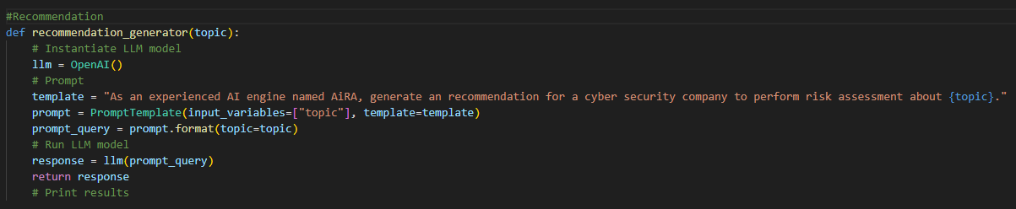

## **Module 3: Infosec agent:**

1. **Llama Index Chat engine:**

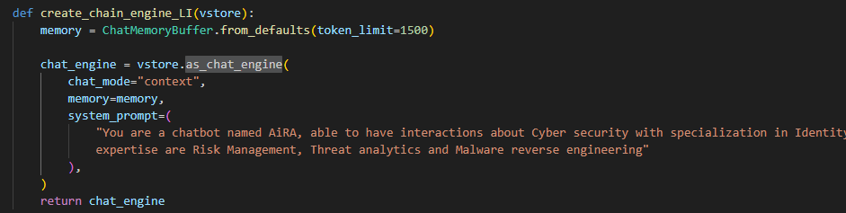

1. **Llama Index React agent using query engine tool**

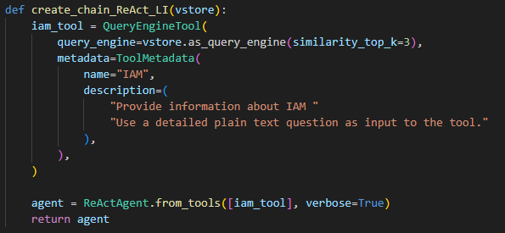

1. **Llama Index Context retriever agent using query engine tool**

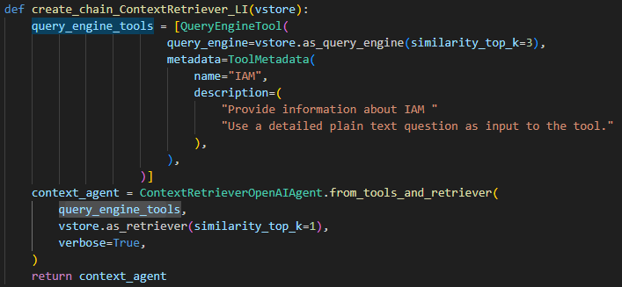

1. **Llama index OpenAIAgent with Duck Duck go tool**

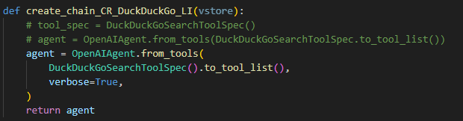

1. **Llama index OpenAIAgent with Google tool**

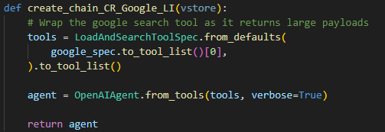

1. **Lang chain – RetrievalQAWithSourcesChain - Agent stacking:**

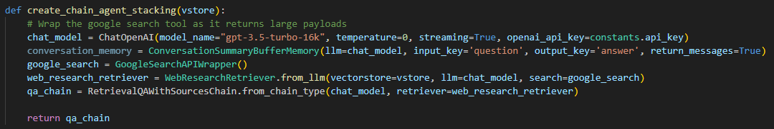

1. **Langchain agent:**

Creates a retrieval-based QA chain using the specified language model, prompt, and vector store. Initializes a retriever and QA model. Defines tools for the agent to use and creates an agent executor.

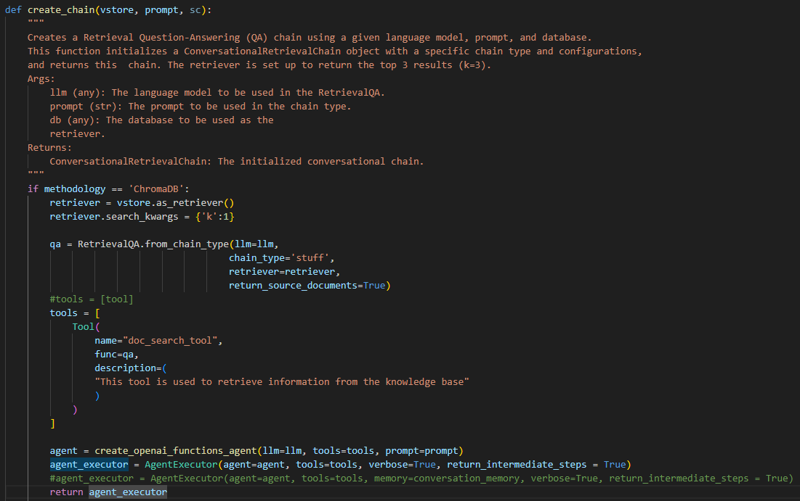

## **Module 4: Conversational agent – Lang chain – Context awareness**

1. Context aware :

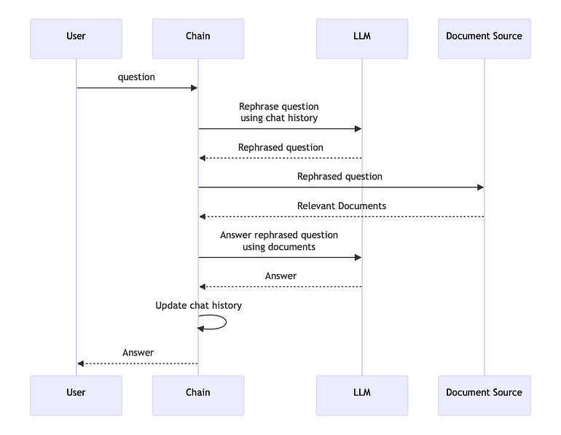

<https://python.langchain.com/v0.1/docs/use_cases/question_answering/chat_history/>

1. Document finder:

* Create retriever

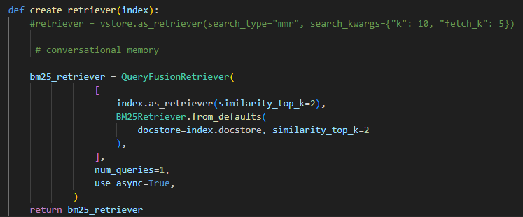

* Create index on the document repository and find the document

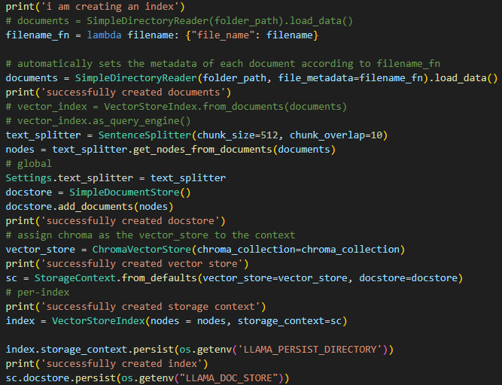

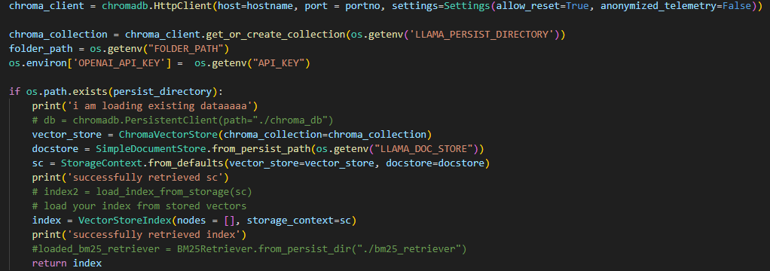

## **Module 5: Fine tuning:**

Used bits and bytes config with 4 pit precision during the training phase. Gemma model for fine-tuning.

**Used Gradient Checkpointing:** This is a technique used to reduce memory usage during the training of deep learning models. Normally, during backpropagation, intermediate activations are stored in memory to compute gradients. Gradient checkpointing saves memory by only storing certain intermediate activations and recomputing others during the backward pass.

Benefits: By enabling gradient checkpointing, you can train larger models or use larger batch sizes within the same memory constraints.

**k-bit Training**: Refers to training models with quantized weights where each weight is represented with k-bits (e.g., 8-bit or 4-bit) instead of the usual 32-bit floating-point numbers. This technique significantly reduces memory usage and can speed up training and inference times.

Leveraged DeepSpeed API - distributed training, mixed precision, gradient accumulation, and checkpoints.

<https://www.deepspeed.ai/training/>

**SPO, PPO:**

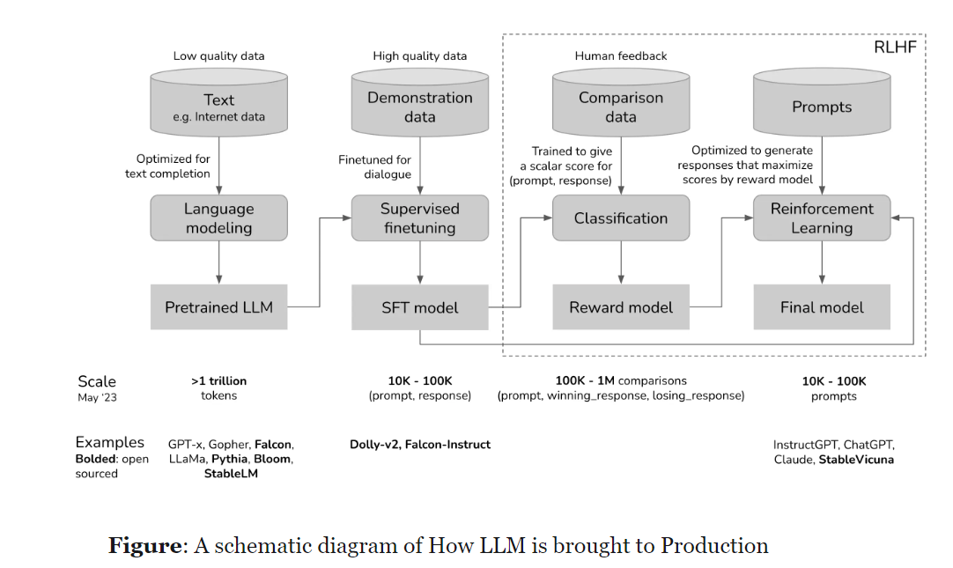

## **Module 6: Choosing vector database**

HNSW

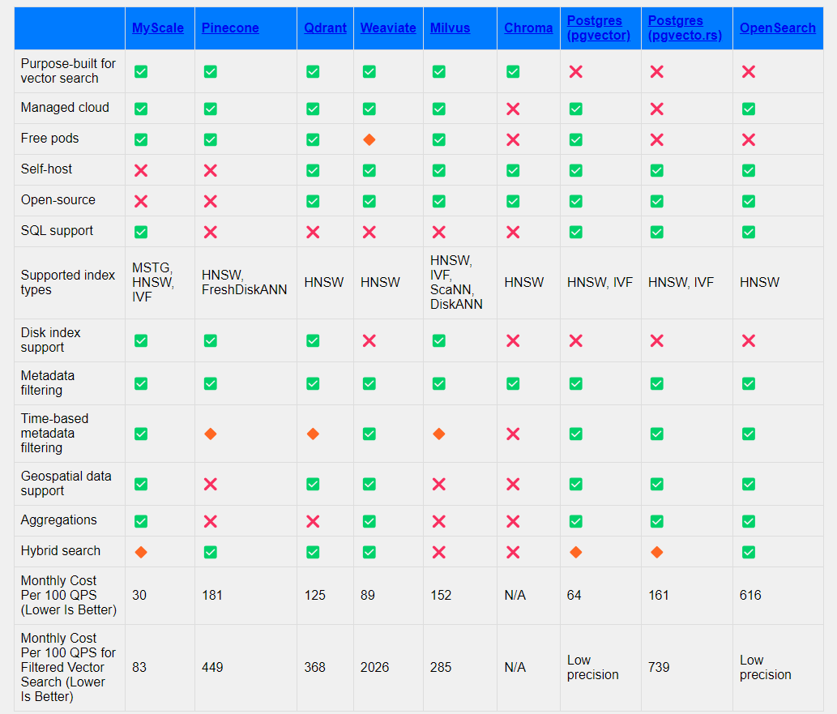

## **Module 7: Indexing, Retrieval, Hybrid search**

Retrieval:

<https://docs.llamaindex.ai/en/stable/examples/retrievers/ensemble_retrieval/>

BM25 retriever along with document source

Indexing:

Hybrid search:

## **Module 8: Presentation engine**

## **Module 9: Fast API – PDF data source Discrepancy checker**

## **Module 10: Unittest with python**

## **Module 11: Azure function apps**

## **Module 12: Snowflake Database**

1. Architecture for snowflake:

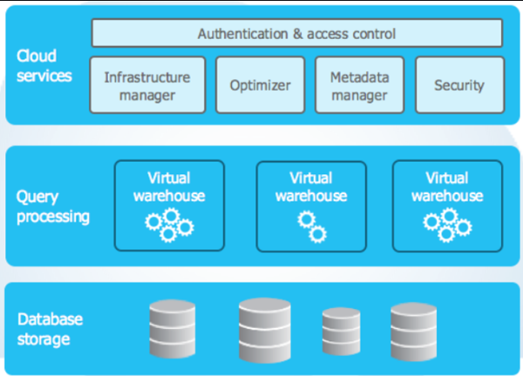

1. Key feature under snowflake:

* Warehouse – where we can create the different configurations
* Storage - Database, table, schema, worksheet
* Zero copy – underline data will not be copied, so the storage will not be doubled. Useful for testing, QA environment’s.
* Semi-structured data – can load the json data and format to the structure one with the help of views for further analysis/
* Time travel – can undone the changes like ‘undrop’
* Can role back the updates to the previous history
* Role based access to the user
* Private sharing - Inbound and outbound data access
* Market place

1. Special about snowflake: <https://www.youtube.com/watch?v=IocdgUB94KQ>

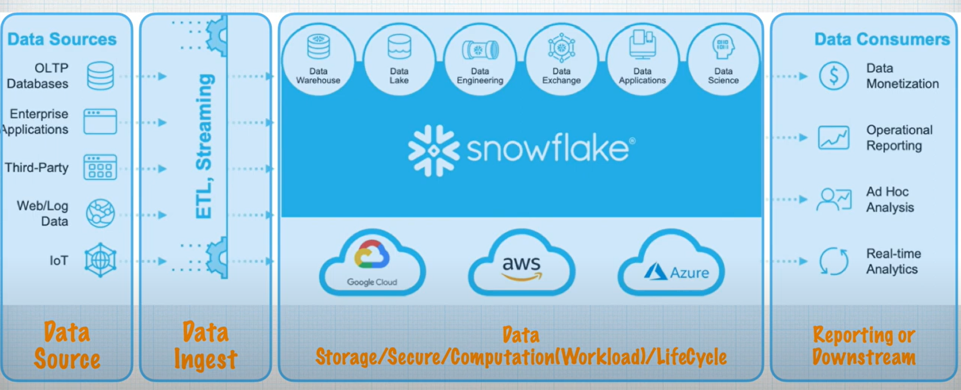

* Feature 1 – major cloud platform support
* Feature 2 – unlimited storage and compute
* Feature 3 – Data platform as service
* Feature 4 – unique 3 layer architecture
* Feature 5 – Virtual warehouse (compute)
* Feature 6 – support for structured and semi-structured data
* Feature 7 – Time travel feature and fail safe

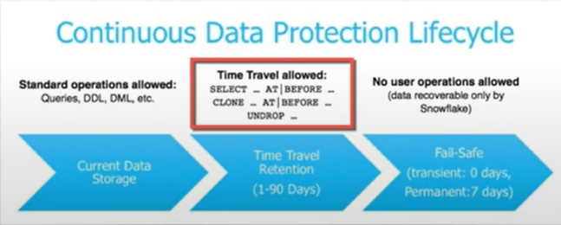

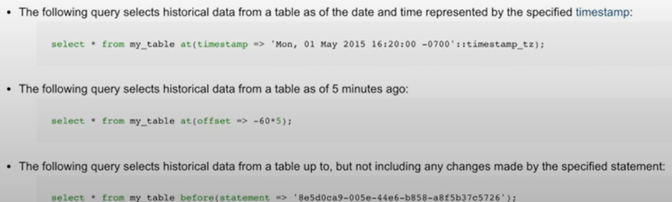

* Feature 8 – clone or zero copy clone
* Feature 9 – Continuous data loading via snow-pipe/stream/task
  + Snow-pipe –**CDC or micro-batch use cases** to load the data from the S3, azure blob
* Feature 10 – ANSI SQL + Extended SQL
* Feature 11 – Micro-partition and data clustering
* Feature 12 – data encryption and security (MFA, Https access, key rotation, Ip whitelisting, query history)
* Feature 13 – Role based access control, discretionary access control
* Feature 14 – Data sharing and reader account (
* Feature 15 – Data replication and fail over
* Feature 16 – connectors
* Feature 17 - Partner connect
* Feature 18 - Data marketplace

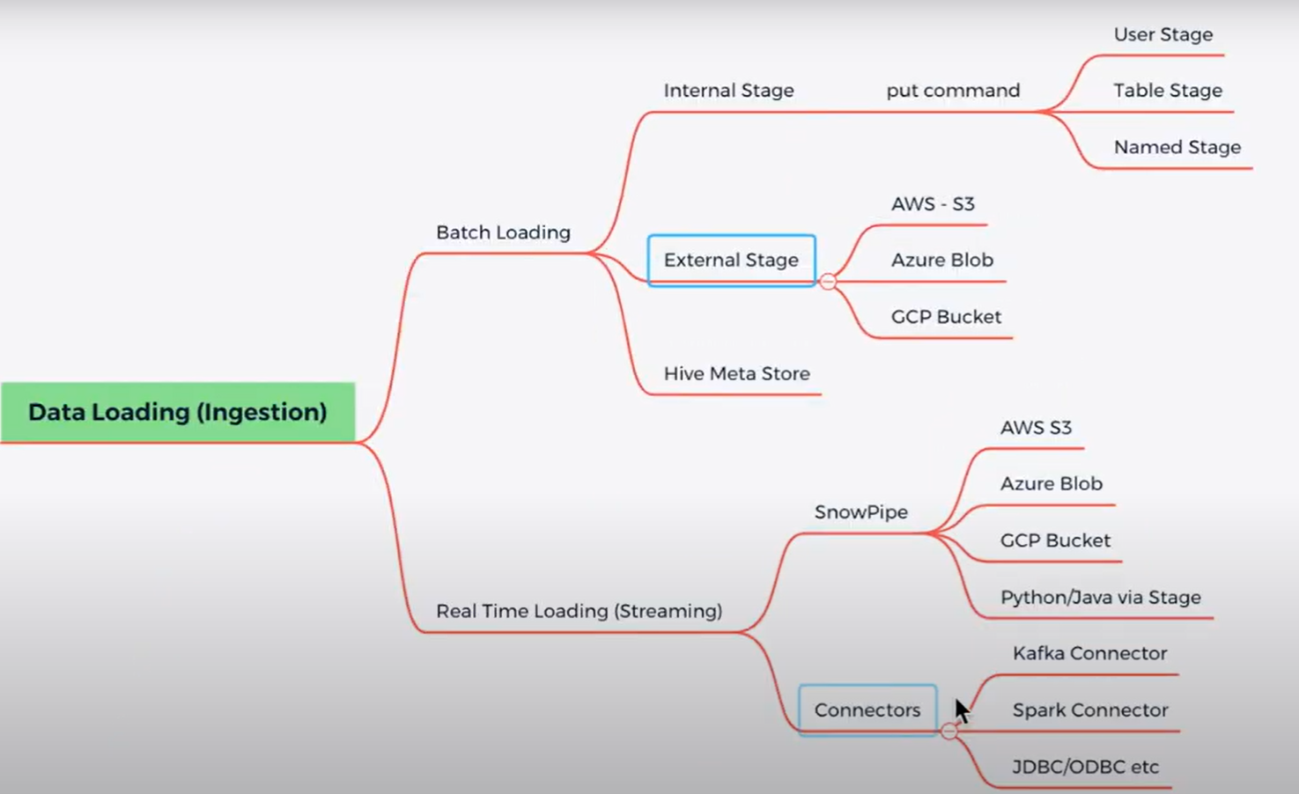

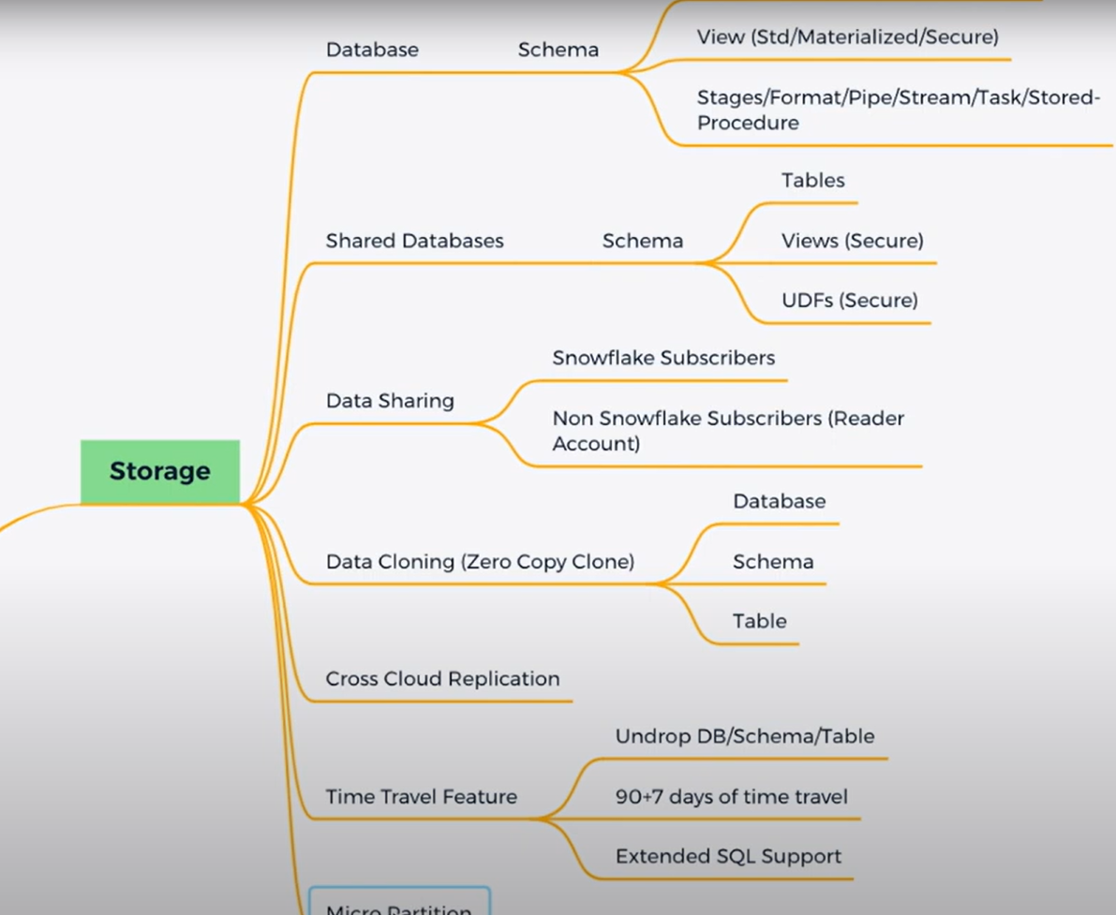

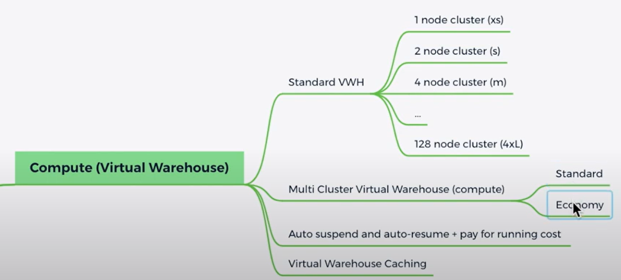

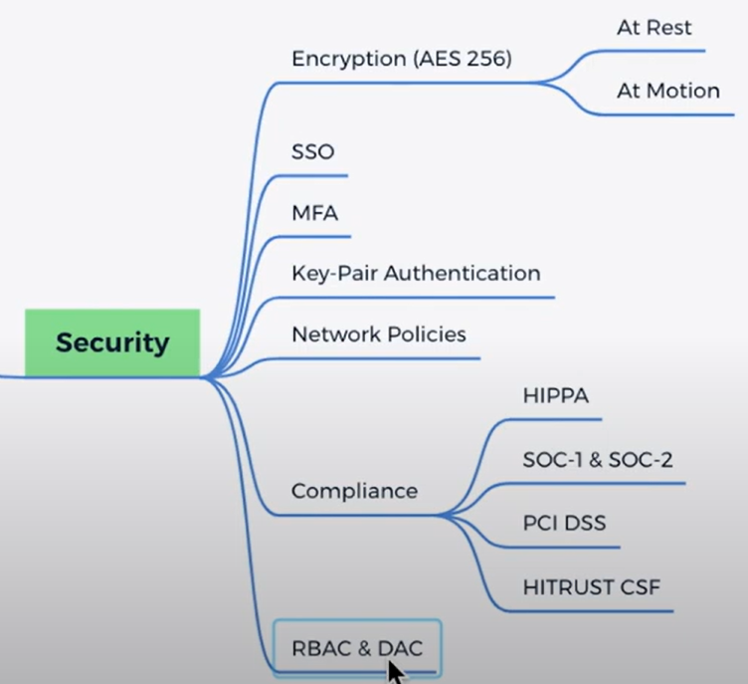 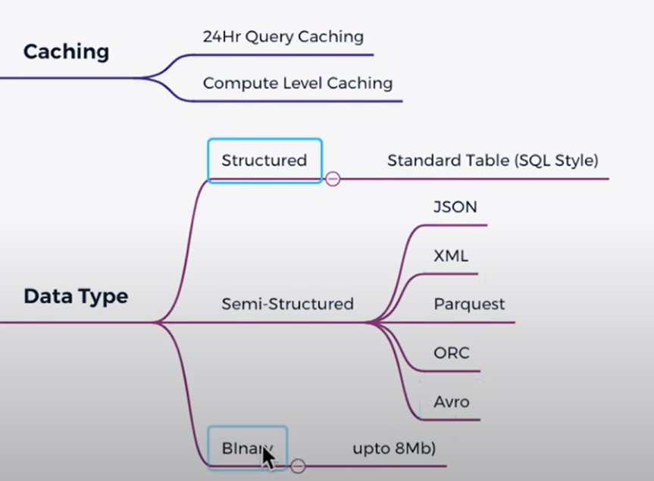

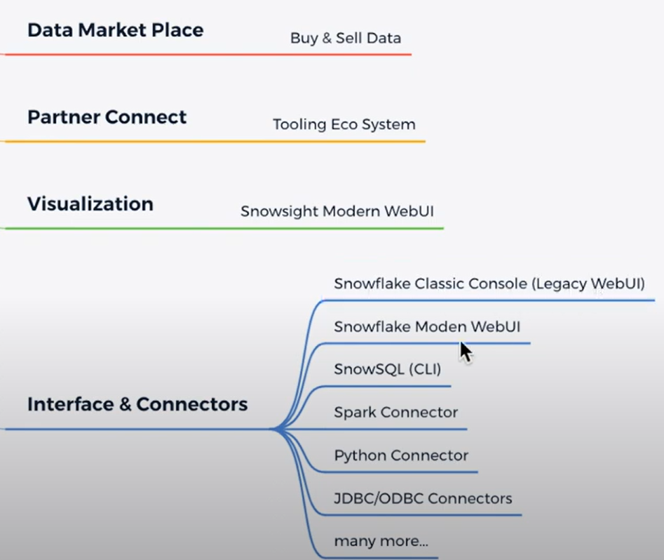

## **Module 13: Seq to Seq Chatbot implementation**

1. Implemented a Seq-2-Seq rule-based Chatbot
2. Controlled flow within the conversations based on decision tree.

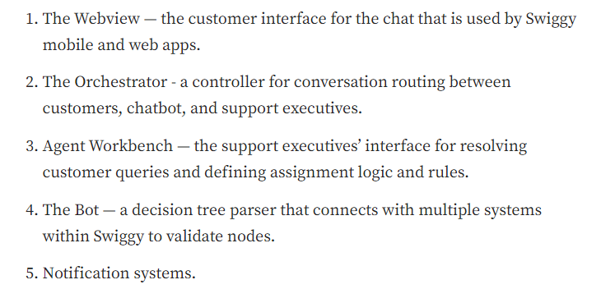

1. Business continuity plan:
   1. Self-serve bot flow – act as an request-response model instead of real-time messenger.
   2. Third party agent chat
2. bot efficacy percentage - percentage of conversations resolved by the bot vs the support executives

<https://www.dragon1.com/concepts/chatbot>

Architecture:

* a presentation layer, containing a chat client and chat UI software.
* a business logic layer, containing a search and retrieval/answering mechanism
* a data layer, containing a database with questions answers, patterns, and templates
* a communication / API layer, containing external API services.

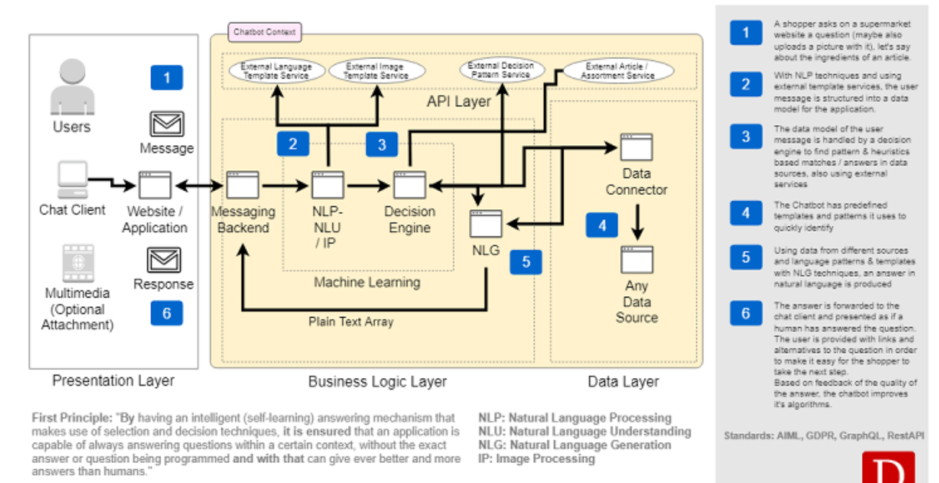

<https://towardsdatascience.com/architecture-overview-of-a-conversational-ai-chat-bot-4ef3dfefd52e>

NLU component:

* Intent classification – Linear SVM
* Entity extraction – Spacy or Stanford library

Dialogue management:

* Interactive learning (reinforcement learning)
* Conversation flow(history with current question)

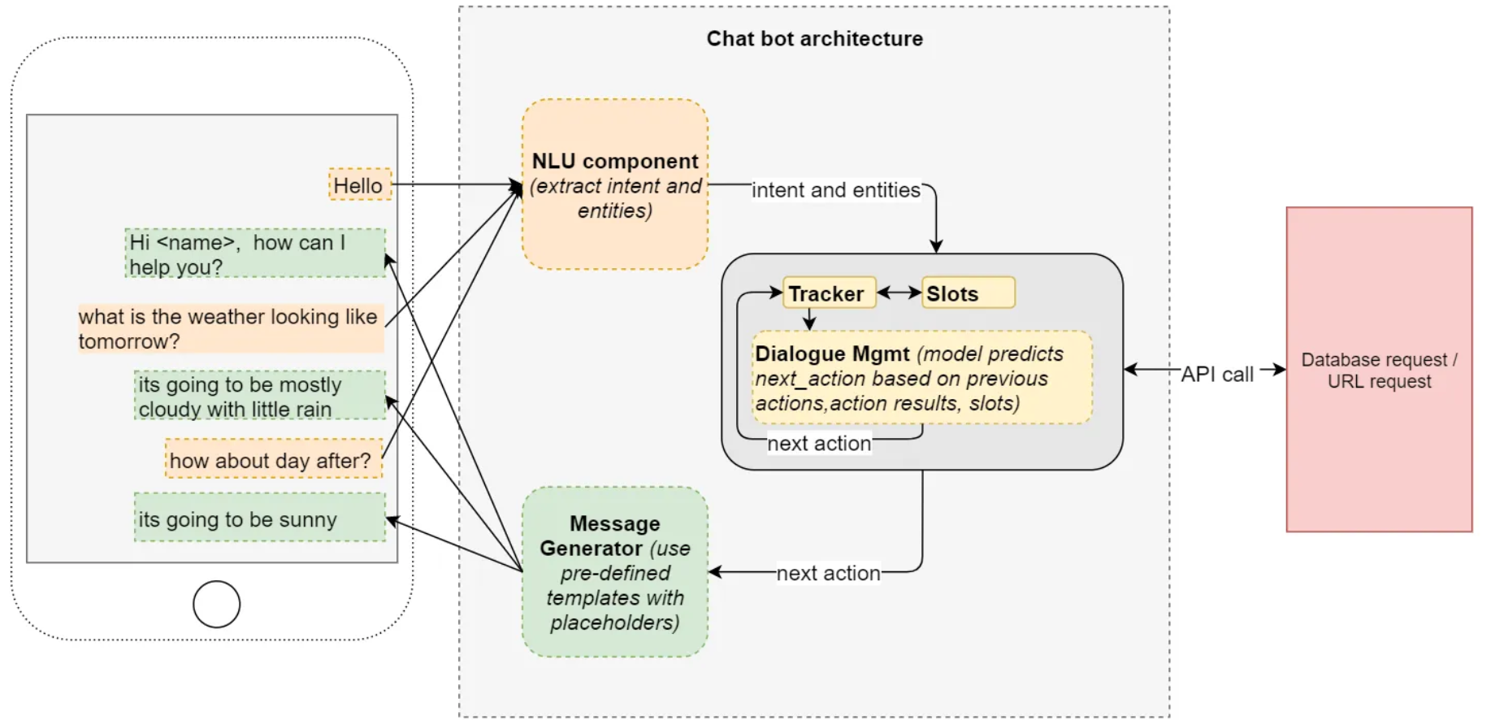

Technica flow: <https://research.aimultiple.com/chatbot-architecture/>

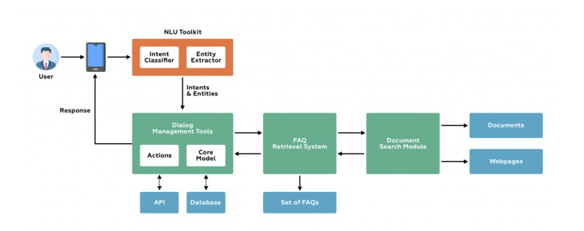

## **Module 14: Chatbot architecture:**

1. Architecture problems:

How good is each of the system as a standalone identity and together.

Inter-operability between the system?

1. Generative AI chatbots:

Chat-like interfaces – openai, gemini, anthropic (full-stack ai platforms)

Good for expert information retrieval.

Create a document, image

Actions – implementing transaction in other system

1. Retrieval based chatbots:
   1. Having a labelled data which can able to classify the user messages to intent
   2. Based on the classified intent, perform an action.
2. Rule-based chatbots:
   1. Dialogflow
   2. Rasa
   3. Amazon Lex
3. Galileo:
   1. Trusted content partners, leadership model
   2. A system should invoke action in another platform
   3. Chatbot look like assistant to use their application
   4. Based on the question, the LLM will be decided
4. Joule:
   1. Ask joule to create a rec, update profile/salary
   2. Context on lifecycle of employee
   3. Manifested the transactions.
   4. Create an AI interface to create documents, give insights on career and feedback, writing assistant.

## **Module 15: Git hub:**

1. **Description, title**
2. **Linked issues**
3. **Look at the code**
4. **Run the code locally**
5. **Communication – approval, rejection, leave comments**
6. **Conflicts, merge issues, squash**
7. **Thank you note to the developer**

## **Module 16: Tech Lead:**

1. Innovating, motivating and advocating for the dev team
2. Engineering managers, stakeholders, members of the team to decide on the frameworks, programming languages and other tools but not decision maker.
3. What should a tech lead do?

* Improve team effectiveness
* Defend team members
* Congratulate team publicly
* Getting team consensus
* Help when things get hard

1. Becoming a tech lead:
   1. Practice defending your team
   2. Practice congratulating team
   3. Read books on leadership
   4. Work closely with others
   5. Learn more about the business
2. Tech lead:
   1. Project planner:

* How to prioritize work
* Who should be working on what
* How to maximize your teams work
* Find out strategy documentation, internal leaders and stakeholders for the project, system requirements
  1. Coach:
* Influencing, mediating, coaching, delegating, advising, persuading, motivating
* Empathy
* No ego
  1. Software engineer:
* Balance individual contributions with overall productivity
* 30% of coding
* Team understand about what going on the project?
* Is there any skill gap on the team?
  1. Main responsibility:
* Review Prs
* Design document
* Review documentation – Processes – to keep it in maintenance mode
* Plan the meeting
* PM task
* Own contribution
* Unblock the developer if they stuck
* Deep focus box - Block time for deep work

# Sales Agent:

## Module 1: Conversation history:

## Module 2: Document finder

## Module 3: Presentation Engine

## Module 4: Regulation controls mapping

## Module 5: LinkedIn Leads identifier

# Wells Fargo - Topic modelling in NLP:

1. Read the monthly incident data from the service desk using pyodbc, ‘stg_incidenr_itds_final_intents’

‘incident_assignmenr_group_unlbl_listed’

• Identified incident ticket categories and sub-c[1]ategories by applying machine learning to critical fields from within Service Now, ranging from a single field to multiple fields; resulted in ~5 times more categories than Service Now, making the data much more granular and actionable.  
• Supported the creation of dashboards in Power BI to convey the categories for File Transfer Services, Enterprise Logging, IT Service Desk, Virtual Desktop, Enterprise Voice, Enterprise Wireless; served as relationship manager for these same partners; total analyzed annual incident ticket volume 3.6M.  
• Benefits from the AI/ML IT Service Desk saves resulting from dashboard automation was 5 FTE’s; dashboard also has enabled a totally different conversation through LOB drilldown of the data.

* + Built and automated a robust Natural Language Processing (NLP) model generating accurate core and sub-intents from large text data of around 350k rows. Ensemble models including Latent Dirichlet Allocation (LDA) and K means model have been used to achieve accurate results. Later creatively utilized Linear SVC model to create supervised automated intent generation with 93% accuracy.  
      
    Reduced 60 hours per month worth of manual effort by building and operationalizing automated Capacity and Utilization dashboards using SPC Charts - logic created in Python, consolidating various data sources from SQL Server and SharePoint, and published on Power BI report server.  
      
    Collaborated and led intensive discussions during Scrum events for improving quality of deliverables, efficiency for the team and being more agile.

1. Read the splunk data - Reported weekly Splunk health metrics which was used to generate extensive predictive analytics for the enterprise logging tool, Splunk; enabled the Splunk team to identify which queries were driving up consumption due to poor practices.
2. Identify the coleaced brand.
3. LDA algorithm – Intuition:

# Optum – Chatbot:

# Optum – Agent call note summarization:

# ITC – Sentiment analysis:

# Cognizant Fraud analysis in NLP:

* Designed and built Extract-Transform-Load (ETL) pipeline/Data flows to retrieve Credit Card Fraud data from 3 different sources, cleaning and transforming data using PySpark and deploying it using Apache Airflow.
* Performed Explanatory Data Analysis (EDA) on the cleaned data to find patterns and correlation between all the independent variables versus Target variable.
* Trained a variety of classifier models such as XGBoost, Random Forest, Support Vector and Logistic Regression model in Python to achieve highest accuracy and a balance of Precision and Recall.

# Key concepts to know in NLP:

1. Tokenizer:

<https://huggingface.co/docs/transformers/en/tokenizer_summary>

Converts the word into numbers

* Word-based – may result in huge vocabulary. Limiting the vocabulary can result in unknown representation which could result in loss of information.

Couldn’t identify that DOG/DOGS are similar.

* Character based – split into characters. Very small character list. Fewer out of vocabulary words. Have to use multiple token to make sense of the word. Size of the context will be more.
* Sub-word-based tokenizers – frequent words should not be split. Rare words should be decomposed.

1. Word-Piece ( BERT/DistilBERT)

Initialize the vocabulary. Progressively learns a given number of merge rules.

Instead of frequency, **maximize the likelihood** of the training data.

WordPiece first initializes the vocabulary to include every character present in the training data and progressively learns a given number of merge rules. In contrast to BPE, WordPiece does not choose the most frequent symbol pair, but the one that maximizes the likelihood of the training data once added to the vocabulary.

1. Unigram (XLNet, ALBERT)

In contrast to BPE or WordPiece, Unigram initializes its base vocabulary to a large number of symbols and progressively trims down each symbol to obtain a smaller vocabulary. The base vocabulary could for instance correspond to all pre-tokenized words and the most common substrings.

Unigram saves the probability of each token in the training corpus on top of saving the vocabulary so that the probability of each possible tokenization can be computed after training. The algorithm simply picks the most likely tokenization in practice, but also offers the possibility to sample a possible tokenization according to their probabilities.

1. Sentence-piece(Albert, XlNet, T5)

No space between the two words.

1. Byte pair encoding (GPT2, RoBERTa)

BPE relies on a pre-tokenizer that splits the training data into words. After pre-tokenization, a set of unique words has been created and the frequency with which each word occurred in the training data has been determined. Next, BPE creates a base vocabulary consisting of all symbols that occur in the set of unique words and learns merge rules to form a new symbol from two symbols of the base vocabulary. It does so until the vocabulary has attained the desired vocabulary size



# ML ops:

<https://techcommunity.microsoft.com/t5/ai-machine-learning-blog/an-introduction-to-llmops-operationalizing-and-managing-large/ba-p/3910996?WT.mc_id=academic-0000-alfredodeza>

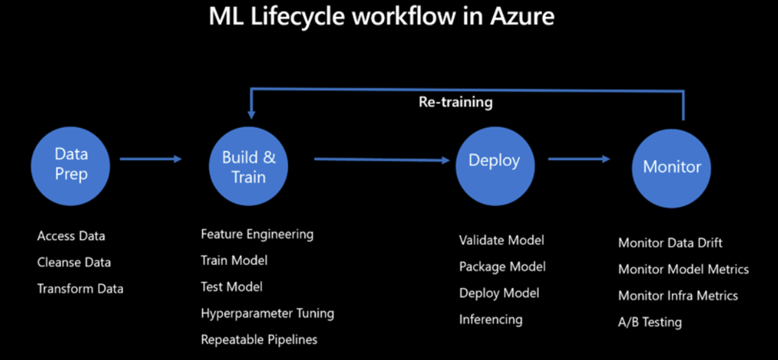

# Training parameters:

1. Gradients:

Gradients are the derivatives of the loss function with respect to the model parameters (weights). In essence, they indicate the direction and rate at which the loss function is changing based on the current values of the weights.

1. Optimizer:

Optimizers are algorithms or methods used to adjust the weights of the model based on the gradients calculated from the loss function. They define how to use the gradients to update the model parameters in order to minimize the loss function.

* Gradient descent – update the model weights after an epoch
* Stochastic gradient descent - update the model weights after a each sample
* Mini-batch SGD – update after the set of records
* SGD + Momentum – gradient decrease in a same directions especially when the patterns follows
* SGD + Momentum + Acceleration – decelerate the weight updates
* AdaGRAD (Adaptive learning rate) – weight will explode and there may not be any learning.
* Adadelta – extra gamma parameter to weight not explode and the learning rate will reach zero
* Adam – Adadelta + Momentum – add expected value of past gradients

# Finetuning LLMs:

1. When to use finetuning:

If prompt engineering doesn’t work. And you have instruction dataset.

FT – will be best for customizability and control.

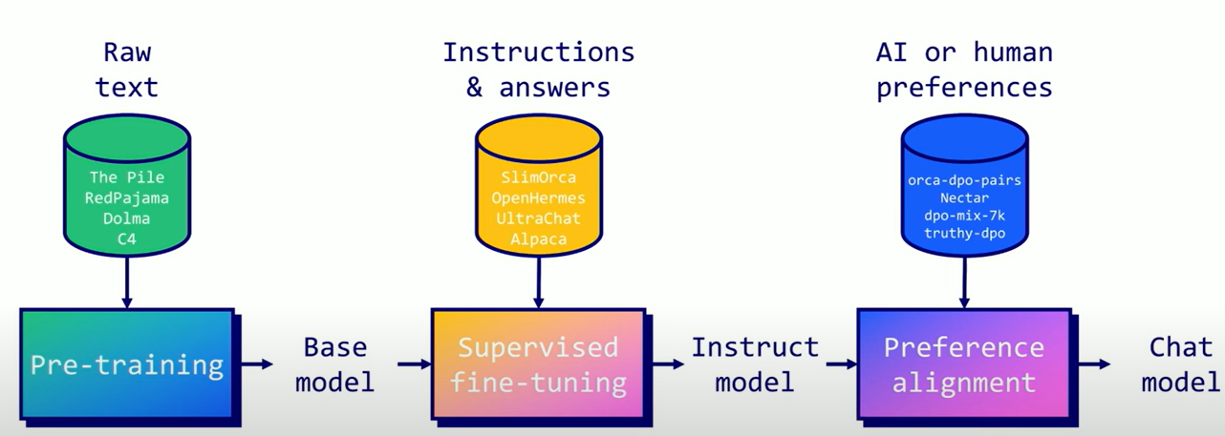

Libraries: TRL, Axolotl, LLAMA-Factory, Unsloth

Preference alignment – PPO, DPO, KTO, IPO

**Creating SFT datasets:**

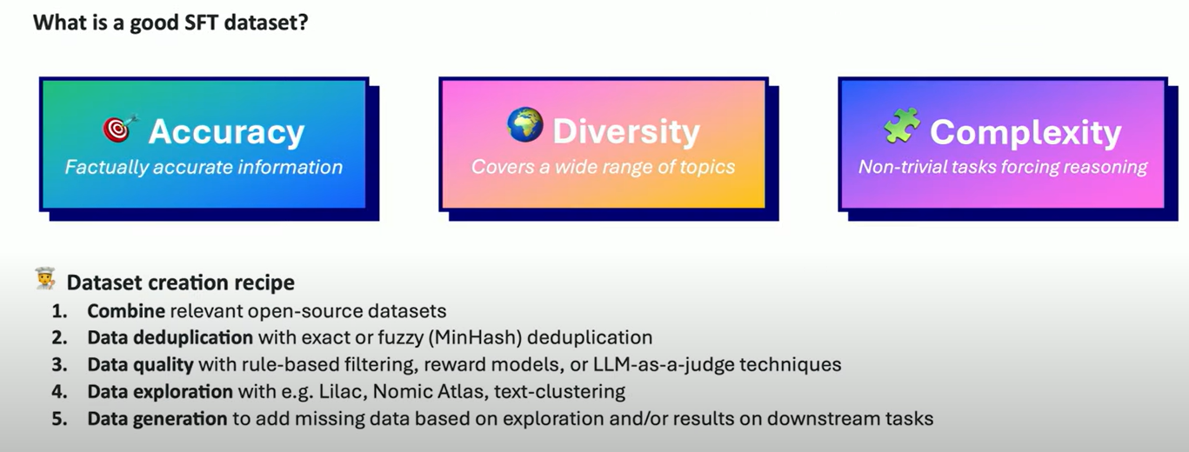

**SFT Techniques:**

Full finetuning, LoRA, qLoRA

1. Model merging and Mixture of experts(MOE)
   1. Model kit – SLERP, DARE TIES
   2. MoE based on Router
2. Quantization – process of converting from high memory to low memory format

* Full precision/ Half precision

Full precision – FP 32

Half precision – FP16

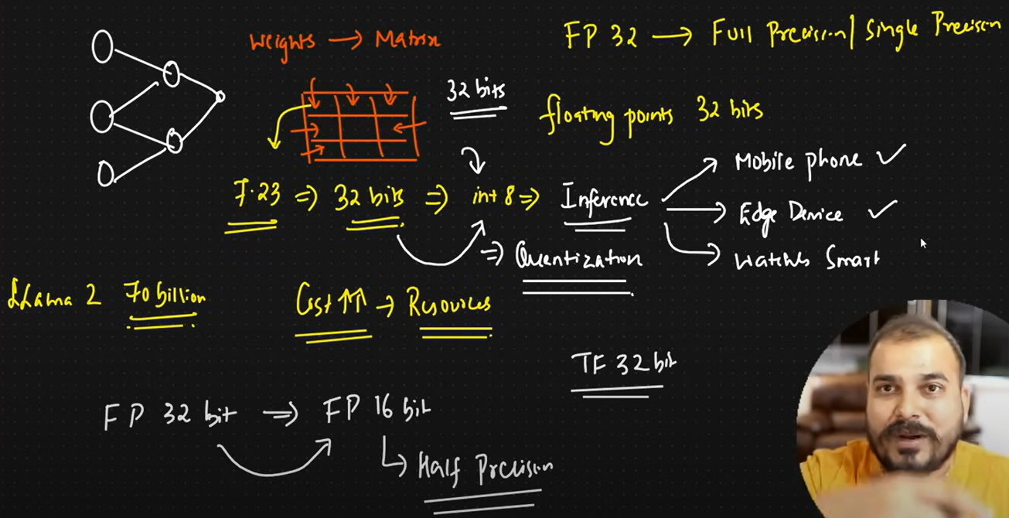

* Symmetric quantization:

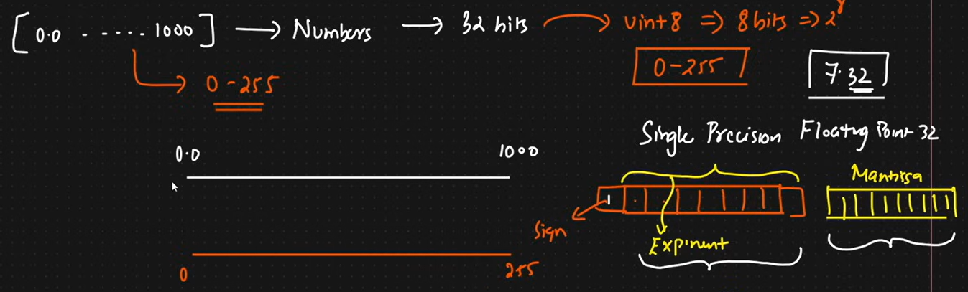

Min_max_scaler =

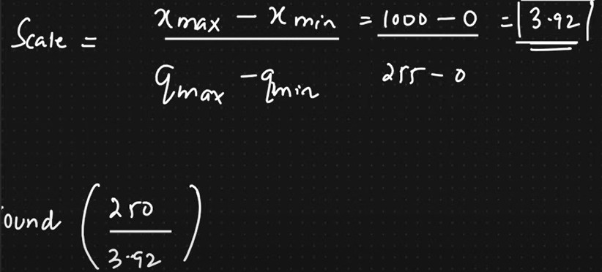

Scaling factor is the factor which will be used to scale from higher to lower precision.

If the values are equally ranged between the upper and lower limit then its called symmetric.

* Asymmetric:

If the range is not equal then its called asymmetric.

Zero point is used to make the start point to align with the new range.



* Calibration – Model quantization problems

The process of squeezing the value within the range is called calibration.

* Modes of Quantization

Post training quantization:

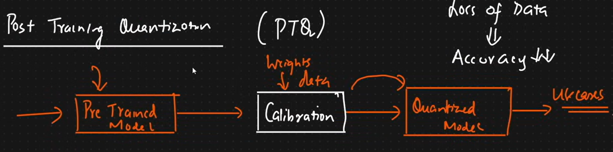

Quantization aware training:

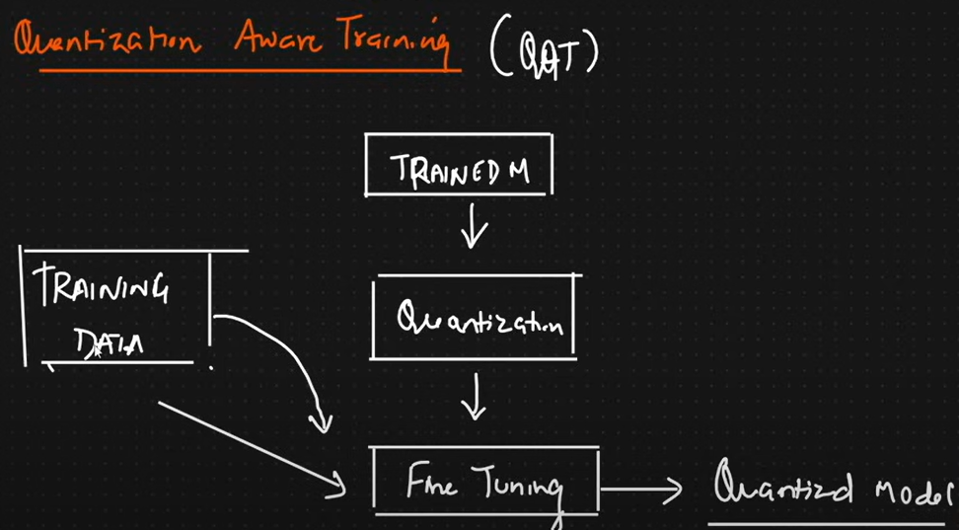

1. QLoRA/LoRA:

# Advanced Python:

1. Magin methods:

Dunder methods: __call__, __init__, __repr__



1.